Name:- Ritik Raj Gupta

Regis:- 12324255

Mock-ups the responsive design parameters for all pages

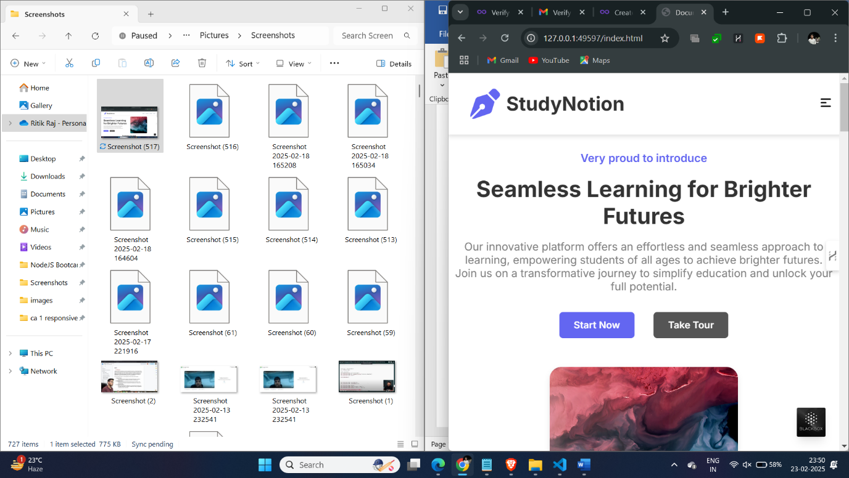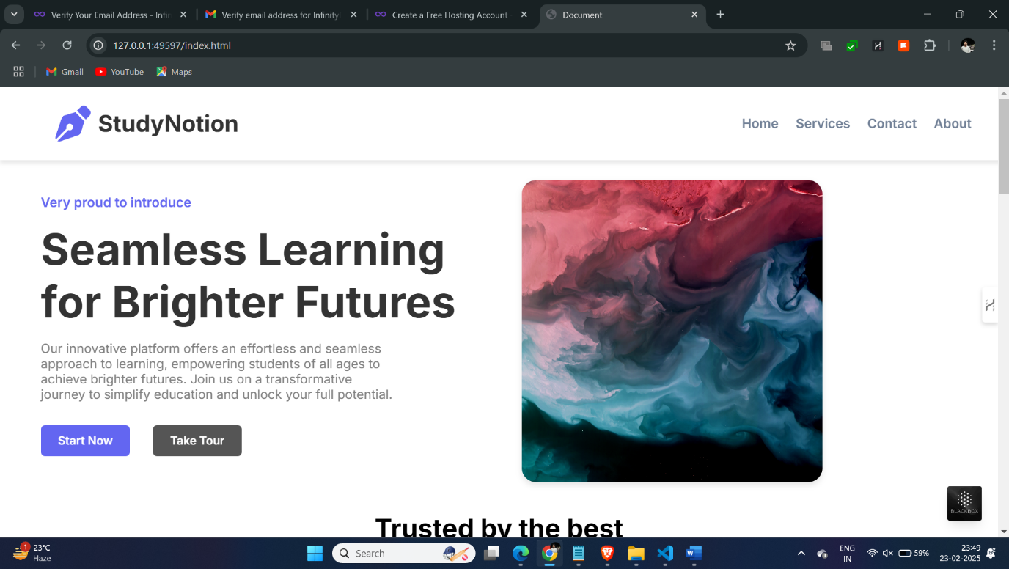

**1. Navigation Bar & Logo Styling**

**Implementation Details:**

.header {

    position: fixed;

    top: 0;

    left: 0;

    width: 100%;

    height: 100px;

    transition: all 0.3s ease-in-out;

    background-color: var(--background-color);

    padding: 1rem 2rem;

    z-index: 1000;

    box-shadow: 0 2px 10px rgba(0, 0, 0, 0.1);

}

**Key Features:**

* Fixed positioning for consistent navigation
* Smooth transitions for interactive elements
* Box shadow for depth
* Z-index to ensure navigation stays on top

**Logo Styling:**

.logo {

    display: flex;

    align-items: center;

    gap: 0.5rem;

    text-decoration: none;

    color: var(--text-color);

}

.logo-icon {

    width: 40px;

    height: 40px;

    transition: transform **0.3s ease;**

**}**

**2. Header Formatting**

**Typography and Spacing:**

html {

font-size: 16px;

scroll-behavior: smooth;

}

body {

min-height: 100vh;

text-align: center;

background-color: var(--background-color);

padding-top: 120px;

line-height: 1.6;

}

**Features:**

* Responsive font sizing using rem units
* Smooth scrolling behavior
* Proper spacing and alignment
* Consistent line height for readability

**3. Responsive Design Implementation**

**Media Queries:**

@media screen and (max-width: 768px) {

    .nav {

        position: fixed;

        top: 100px;

        left: 0;

        width: 100%;

        background-color: var(--background-color);

        padding: 1rem;

        flex-direction: column;

        gap: 1rem;

        transform: translateY(-100%);

        opacity: 0;

        visibility: hidden;

        transition: all 0.3s ease;

    }

}

**Key Breakpoints:**

* **Mobile: < 768px**
* **Tablet: 768px - 1024px**
* **Desktop: > 1024px**

**Responsive Images:**

img {

    max-width: 100%;

    height**: auto;**

**}**

**4. Interactive Elements**

**JavaScript Implementation:**

document.querySelectorAll('a[href^="#"]').forEach(anchor => {

    anchor.addEventListener('click', function (e) {

        e.preventDefault();

        const target = document.querySelector(this.getAttribute('href'));

        if (target) {

            target.scrollIntoView({

                behavior: 'smooth',

                block: 'start'

            });

        }

    });

});

**5. Footer Implementation**

**Structure:**

.footer-container {

    background-color: var(--light-gray);

    padding: 4rem 2rem;

    margin-top: 4rem;

}

.footer-grid {

    display: grid;

    grid-template-columns: repeat(auto-fit, minmax(200px, 1fr));

    gap: 2rem;

    padding: 2rem 0;

}

**Features:**

* Responsive grid layout
* Proper spacing and alignment
* Hover effects on links
* Mobile-friendly design

**6. CSS Variables for Consistency**

:root {

    --primary-color: #6366F1;

    --accent-color: #3f83f8;

    --text-color: #333333;

    --link-color: #2563eb;

    --background-color: #ffffff;

    --light-gray: #f0f0f0;

    --gray: #808080;

    --dark-gray: #555;

}

**7. Browser Independence**

**CSS Reset:**

* {

    margin: 0;

    padding: 0;

    box-sizing: border-box;

    font-family: 'Inter', sans-serif;

}

**Key Features Demonstrated:**

1. **Responsive Design:**

* Fluid layouts using Flexbox and Grid
* Mobile-first approach
* Breakpoint-based design

1. **Performance Optimization:**

* Optimized images
* Smooth transitions
* Efficient CSS selectors

1. **User Experience:**

* Smooth scrolling
* Interactive elements
* Consistent spacing
* Clear typography

1. **Accessibility:**

* Semantic HTML
* Proper contrast ratios
* Keyboard navigation support

5. **Cross-browser Compatibility:**

* CSS reset
* Vendor prefixes
* Fallback properties

This documentation provides a comprehensive overview of the responsive website implementation, highlighting key features and technical details that demonstrate the fulfillment of all requirements. The code snippets can be used to explain specific implementations during the presentation.